Mildura Vintage Vehicles Club Inc.
Cordially invites you the Enthusiast and Collector of Special
Interest Vehicles to the
22nd Biennial Easter Vineland Rally 14th to 17th April 2017
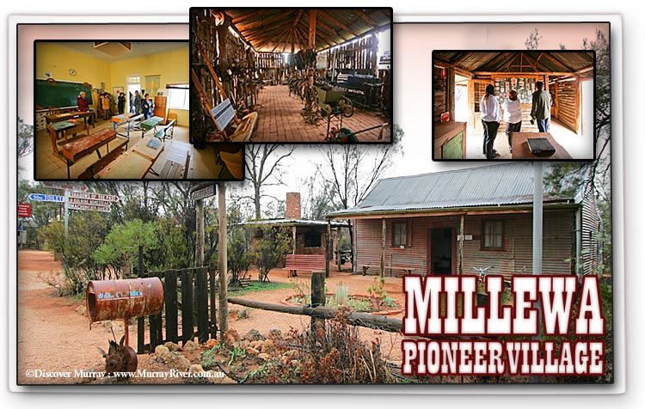

Rally Committee
Don Carr ................................................................................0400235431
Allan Hassett ....................................................................0350 228818
Brian Jory ...........................................................................0407845459
Marjory Kissick ..............................................................0350 238590
General Information
- Payment of entry fee and meals to accompany entry by closing date, 6th March 2017. Enter and pay by 6th February to receive early bird discount.
- Vehicles less than 25 years may enter, but are not eligible for judging.
- Registration will be at the Club rooms of the Mildura Vintage Vehicles Club, Wilkinson Hall, cnr Burns & Williams Street, Gol Gol, NSW from 1:00-5:00pm, Friday 14th April. Afternoon tea supplied. Meet, greet, social evening and light meal will be held at the club rooms at 7pm.
- Update information will be in the Rally Packs at Registration Point. Those not collected Friday will be available on Saturday.
- The theme for night will be Rock & Roll wearing of those costume is encouraged and will be judged on Friday night at the Club rooms.
- Starting Point on Saturday morning will be on the lawns at the Buronga Wet lands area. Please arrive to display your car by 10am. Official opening will take place at 1030am. followed by the judging.
- Lunch will be served at the Wetlands at 1215pm. On completion of lunch we will drive out through back blocks of Dareton via Fletchers Lake road back towards Wentworth and Curlwaa then back to Buronga via the River road ending up at Ron Morrello's Holden Motor Museum 3pm. The cost to enter will be $6.00 Approximately 100 kms for the drive.
- Saturday nights meal will be at the Red Cliffs Civic Centre. BYO drinks.
- Sunday morning will start off at the Club rooms in Gol Gol. Cars to Arrive from 9am. onwards for a departure at 10am. for older cars.
- The run on Sunday will include a trip to Millewa Pioneer Village and will be approximately 200kms return trip. Lunch will be served at the Village.
- The Presentation Dinner will be held at the Mildura RSL in Madden Ave, at 6.30pm. Car parking at the side of the building entry at Madden Ave.
- Breakfast on Monday Morning will be at the Club rooms from 7.30am. onwards

Accommodation
For other information, or reservations please contact the Mildura Tourism Centre: (03) 50188 380 or free call 1800 039 043
Website- tourism@mildura.vic.gov.au or visitmildura.com.au

Mildura Vintage Vehicles Club Inc.
22nd Biennial Easter Vinland Rally
14th to 17th April 2017
ENTRY FORM
Entries close 6th March 2017. Early Bird Entries close 6th February 2017
Name ........................................................................................................................................................................
Postal Address..........................................................................................................................................................
....................................................................................email ...................................................................................
Phone..........................................................................Club......................................................................................
Vehicle Make................................................................................Year...................................................................
Model.......................................................Body Style..............................................................................................
Registration Number........................................ Drivers Name............................................................................
Passengers Names:
Adults............................................................ Children.......................................................................................
............................................................ ....................................................................................
 | Adults |  | Children |  | Sub.....  Total
 | Number | $ | Number | $
Friday Social |  | Free |  | Free
Saturday Lunch |  | $10.00 |  | $10.00
Saturday Dinner |  | $20.00 |  | $10.00
Sunday Lunch |  | $10.00 |  | $10.00
Sunday Dinner |  | $32.00 |  | $16.00
Monday Breakfast |  | Free |  | Free
ENTRY FEE | $75 /OR
EARLY BIRD ENTRY | $65
ENTRY FEE PER ADDITIONAL CAR  No Rally Pack  Administration Cost | $10
Mildura Holden Motor Museum | $6
TOTAL COST
* Children's price under 12 years

* Please advise of any special dietary
requirements so arrangements can be made.

Payments
Cheque/Money Orders should be made payable to the Mildura Vintage Vehicles Club Inc.
Entry form and payment should be forwarded to
MVVC
EASTER RALLY 2017 Important:
P.O. BOX 1301 Please sign declaration
MILDURA, VIC. 3502 form on reverse side.

Mildura Vintage Vehicles Club Inc.
22nd Biennial Easter Vinland Rally
14th to 17th April 2017
Declaration form
In consideration of this entry, I agree that the Rally Committee and Mildura Vintage Vehicles Club Inc, will no way be responsible for loss and/or damage to a participating vehicle, its parts or accessories and personal effects, or for any damage caused by any participant entering or driving in this rally, or a passenger taking part thereby waive the right of action at law against the Committee, Mildura Vintage Vehicles Club Inc, their representatives or agents.
All vehicles must be roadworthy and display current registration or permit ( no trade plates allowed) and the driver / rider there must hold a current drivers licence applicable to the class of vehicle to be driven or ridden, and appropriate insurance.

Date......................................

Signature of Entrant ...............................................................................................

N.B: This information is a condition of entry acceptance

Office use only
Date received ................................................................................

Rally Entrant Number ...................................................................

Receipt Number ............................................................................

Date Sent ......................................................................................

