The NSW Historic Motoring Association (NSWHMA) (formerly the NSW Southern Motoring Association) is an association of motoring enthusiast clubs that have come together with the common goal of promoting the freedom to continue to use their historic vehicles, to assist clubs in the implementation of ever-changing rules, and to be informed of Government actions that may have impact.

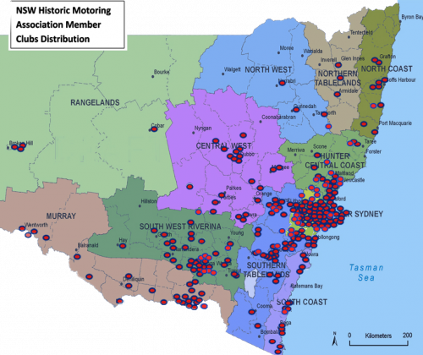
Member clubs are drawn from towns and cities all over NSW. The variety of clubs is the most unique aspect of this Association, with special interests ranging from historic machinery, street machines, hot rods and competition vehicles, omnibuses and trucks, to classic, vintage and veteran cars, and motorcycles, as well as modified vehicles.
Most of our member clubs are not affiliated with other peak bodies, but we do have clubs that are also affiliated with the National Historic Machinery Association (NHMA), or the Australian Street Rod Federation (ASRF), for example. We do not require any club to abandon any existing affiliation to join this Association.
We support the broad approach of our member clubs to their hobby. They have fully embraced the introduction of the Classic Vehicle Scheme (CVS), and the 60-day logbook available to all owners of historic vehicles at their option.
NSWHMA has had a voice at the table of Government through its membership of the Australian Confederation of Motor Clubs (ACMC), an Approved Organisation (AO), which represents a much broader range of interests including 4WD, Street Rods etc. The achievement of AO status in our own right in September 2021 gives us direct access to policy makers and enables us to independently promote our members’ interests. Our strength can only be a reflection of the numbers of clubs and vehicles represented, and we actively encourage unaffiliated clubs to join with us to enhance our representation.
Motoring enthusiasts have a remarkable record of extremely responsible vehicle use, with an astonishingly low rate of insurance claims. We have a special relationship with our vehicles having invested heavily in time, work and money, and we take very good care of them. Our clubs also have an enviable record of contributing to the communities in which we live. The presence of historic vehicles adds to the appeal of fund raising and community events. Bikes or cars, tractors or trucks, motoring enthusiasts love their vehicles and are passionate about their hobby and members of the public clearly derive great pleasure from seeing the vehicles and machinery on show and in use.
This is who we are.

