KERANG & DISTRICT
VINTAGE MOTOR CLUB INC.

NEWSLETTER

P.O.BOX 30 KERANG, VICTORIA. 3579

November 2023

2015

Date of issue
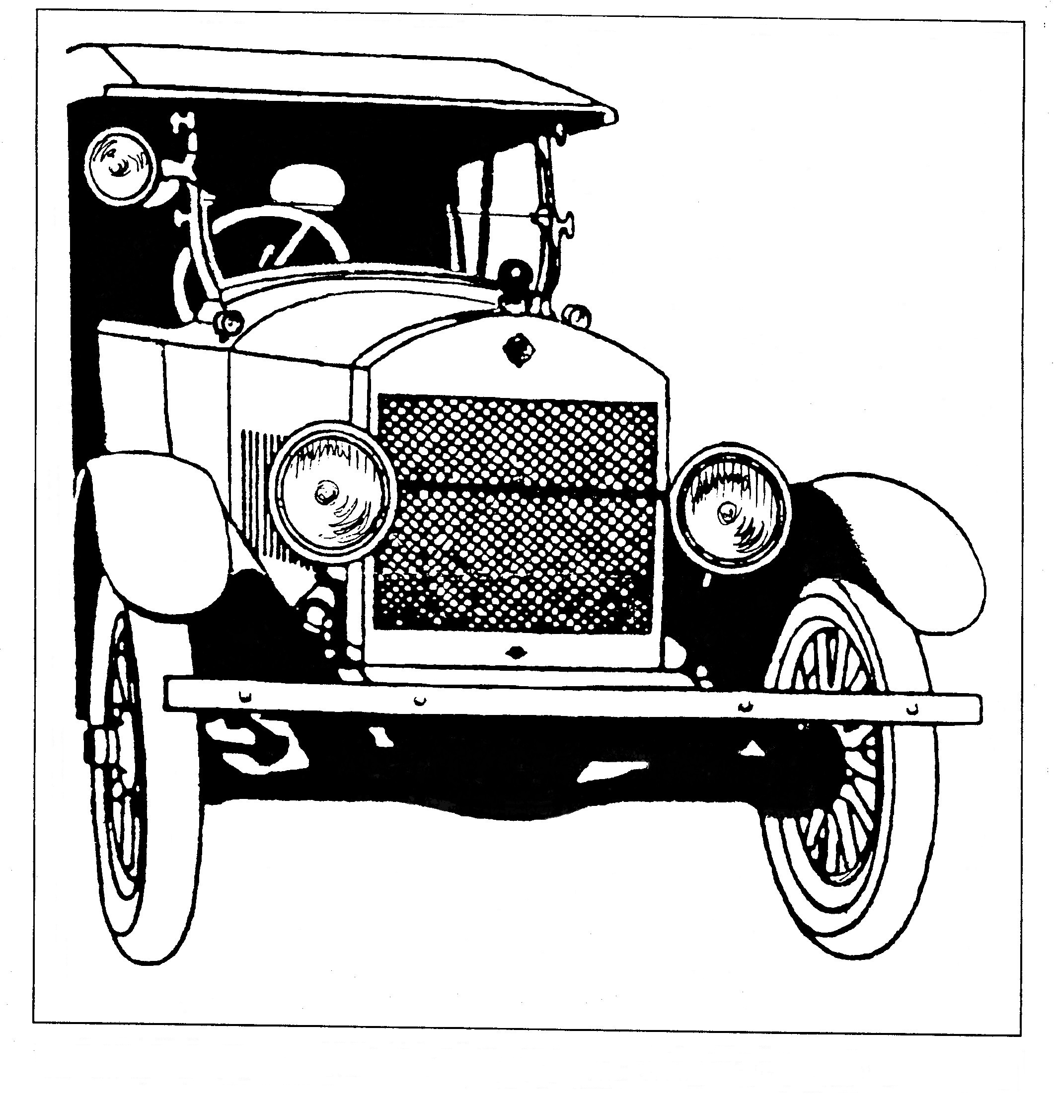

Registered by Australia Post Publication, No VBH 2686, Category B

COMMITTEE & OFFICE BEARERS 2023-2024

PRESIDENT Gary Fowler (Darna) Ph. 0498 699256

VICE PRESIDENT Colin Brown (Marion) Ph. 0428 509010

TREASURER Dianne Moon Ph. 0417 031629

SECRETARY Caren Coates (Rod) Ph. 03 54567509

MINUTES SECRETARY John Mowat (Margie) Ph. 03 54576232
ASSISTANT MINUTES SECRETARY Peter Greenwood Ph. 0409 503722

EDITOR John Ritchie (Tamara) Ph. 0427 344 498 or 03 54522754
E-Mail Address chev1940@bigpond.com.au

ASSISTANT EDITOR Peter Greenwood Ph. 0409 503722

CLUB CAPTAIN Ken Fowler (Shirley) Ph. 0437 874 040

MERCHANDISE OFFICER John Webb (Jan) Ph. 0409 996 512

ASSISTANT MERCHANDISE OFFICER Wayne Hester

CATERING OFFICER John Rumbold Ph. 0458 009622

SCRUTINEERS John Ritchie Ph. 0427 344 498
Greg Southern Ph. 03 54562051
Ken Fowler Ph. 0437 874 040
Gary Fowler Ph. 0498 699256

FEDERATION Bruce Campbell Ph. 0427 532 622
DELEGATES John Goddard Ph. 0427 346 643

Club E-Mail address kerangdvmc@gmail.com

FACEBOOK PAGE Type in Kerang and District Vintage Motor Club.
Kerang & District Vintage Motor Club Inc Banking Details
BSB 633 000 Account Number 53173621 When paying online E-Mail

Kerang and District Motor Club Life Members.
Colin Day - Keith Elliott - John Ritchie - John Mowat - Graeme & Glenda Rumbold – Don Pascoe – Ross Hall – Ken Fowler.

Kerang Car Club Meeting October 2023
Apologies.
Geoff Aldred, Andrew Borkowski, Brenton Brooker, Max Christian, Rod and Caren Coates, John Forbes, Nathan Henry, Peter and Barbara Hildebrand, Murray James, Michael Kelly, Adam Gelletley, David North, Ryan O’Mahony, Daniel Spark, Ted Stalker, Ralph and Julie Steains, Gary Toll, Peter Webb and Bev Wilkinson.
Present.
Mark Arians, Ralph Arlt, Robert Barr, Michael Bell, Max Bowland, Alan Boyle, Terry Brooker, Colin Brown, Peter and Jeanette Byrne, Bruce Campbell, Graeme Clapham, Alan Davies, Colin and Glenda Day, Ross Day, Phillip Day, Bruce and Jenny Dehne, Ken Donat, Phillip Gawne, John Goddard, Colin Granter, Lee Guest, Greg Henry, Wayne Hester, Barry Hogg, Chris Hope, Don Jenkins, Dianne Moon, Andrew Maconachie, Colin McDougall, Alan Mowat, Jacob Nixon, Jill North, Mark Powney, Phillip Reed, Adam Ridley, Graeme Rumbold, John Rumbold, Greg Southern, Don Sutherland, Les Thornton, Gary Nicholson John Ritchie, John Webb, Troy Websdale, Richard Welsh, Greg Wright, Robert and Alisha Gordy.
General Business:
Club member’s cards are available.
The 2024 calendar is being organised and new ideas for trips are needed.
Thank you to the Dingwall Hall committee for the after trip lunch.
The Charlton Show and Shine was on, thanks to the members who attended.
The Kerang Show and Shine has an all weather area, thanks to Reagan O’Brien for donating the gravel and equipment.
The Show and Shine committee talked about having a cruise and BBQ night.
Christmas dinner looks like it will be at the Bower in Cohuna 15th of December @ $45 per head.
Surge thanked everyone who filled in for him after his knee op.
Thanks to Di for the Lakes Entrance report for the newsletter.
Jan Harry asked to mention the Groove on the Green at the Kerang Golf Club and would like some cars to display, 26th of November 4pm to 9pm.
Ganna toy run leaving Leitchville to Kerang for brekkie, smoko in Barham and lunch in Cohuna with Show and Shine.
Ganna L to P program is look for volunteers.
Club Captains Report:
Eight members turned up for the Euroa Show and Shine 3 to 400 bikes over 1000 cars great show to attend.
Club Captains Report
Boort Show had over 100 trucks on display with 12 club cars from Kerang.
Charlton had their Show and Shine with swap.
After trip lunch had 32 members who enjoyed a lovely meal.
Thu 26th club lunch at the Lake Boga pub.
Barham Show and Shine on the 21st.
Moama Show and Shine 29th leaving at 8am.
Bendigo Swap on the 11th and 12th with members volunteering to attend the gate.
18th of November is the Ganna Toy Run.
Fed Report
The Fed report was read out by John Goddard.

Correspondence In
Vic Federation Agenda for meeting held 14th October
Stolen: Vintage BSA 500cc 1936 model W33-7 Engine No. D7.757
At Box Hill, (Melbourne suburb) around AFL grand final weekend (last weekend in September).
Family heirloom having been my late Father’s for 55 years and my Great Uncle’s before that.
Please notify me if you see this bike or spares on the market.
Priceless. Vintage Motorcycle Club of Victoria member in the process of getting club plates.
Rowan Hore Mobile 0428 709 708 or email tennihore@bigpond.com
Notification of the passing of Peter Byrne (of Boort) – past car club member
Various Flyers
Various Newsletters
Correspondence Out
Nil

Presidents report.
Hi Everyone,

I am very sad to start this report with the news of the passing of Jim Spark.
Jim was a respected and popular member of our club for many years that enjoyed many outings and events until ill health prevented him from doing so.
On behalf of the Kerang and District Vintage Motor Club I would like to extend our sincere condolences to Jims family and friends at this very sad time, he will be very sadly missed.

We also recently lost a past member, Peter Byrne (From Boort), on behalf of the Kerang and District Vintage Motor Club, I would like to extend our condolences to Peters family and friends.

I know we are not quite half way through our year but I think that it is time to suggest we will have at least one vacancy on the committee at the next elections. The club can't operate without the hard working people on the committee, so if you think you have something to contribute please think about putting your hand up at the next elections.

The committee is also looking for ideas for next year’s calendar, so if you have a destination or an idea for an event, now is the time to let us know.

As most of you are aware, the Kerang Show and Shine is on April 13th and 14th 2024, we will be looking for people to man the gate as well as park cars.
It has been proposed that we do a cruise night on the 13th followed by a BBQ at the venue along with many other ideas being considered.
Holden’s will be the featured vehicle at this event so if you have a Holden of any model please consider showing it.

Fuel prices have been a bit crazy of late but it's still great to get out for a drive in a toy if you can so I'm looking forward to seeing all of you on a run soon.

Cheers,
Serge.

G.J. & D.A. MACONACHIE

Automotive Electrician
Prop. Gary Maconachie.
(03) 54522305 AH (03)54521712
Mobile 018500173
On Farm Service, Starter Motor, Alternators, Generators, Regulators, UHF Radio’s & Power Tool, Repairs and Rewiring.
AUTO PRO PARTS PROFESSIONAL
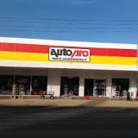
Ph 54521502

Bruce &Nola
Wright

Wellington St Kerang

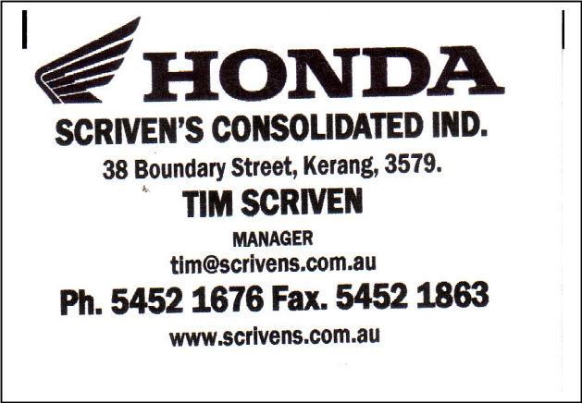
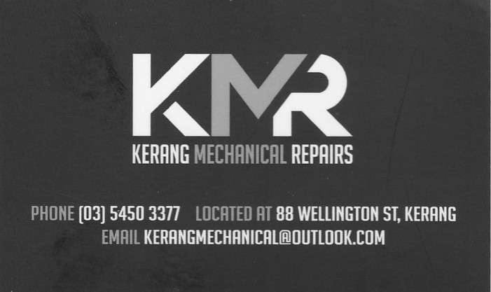

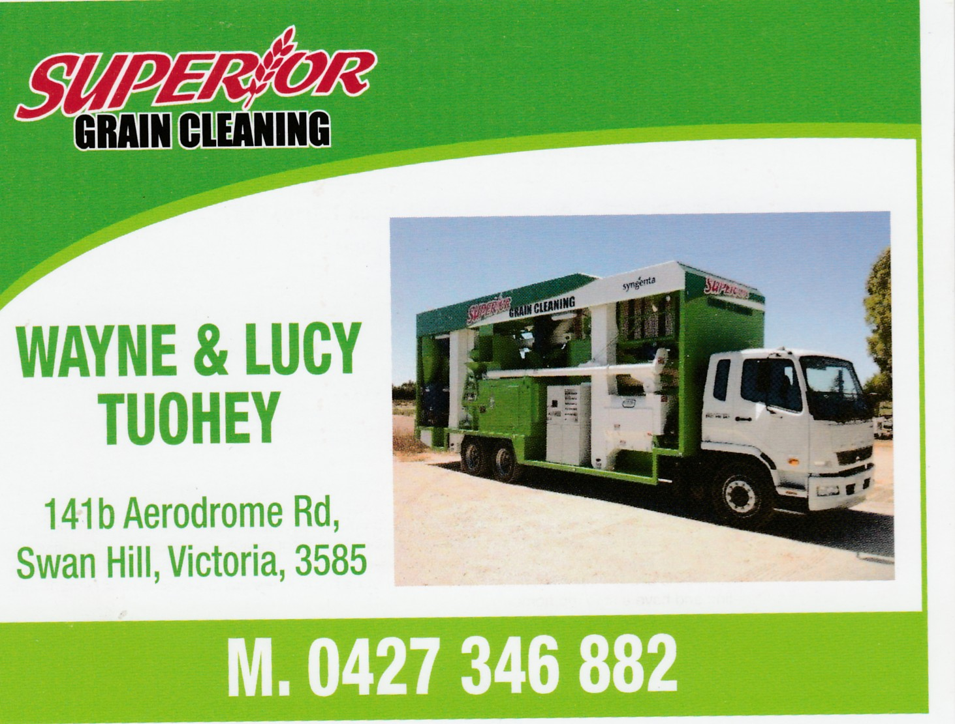

Arnoldt & Greenwood
Kerang Towing Service’s
Ph 0354503711
Kerang’s Careful Carriers

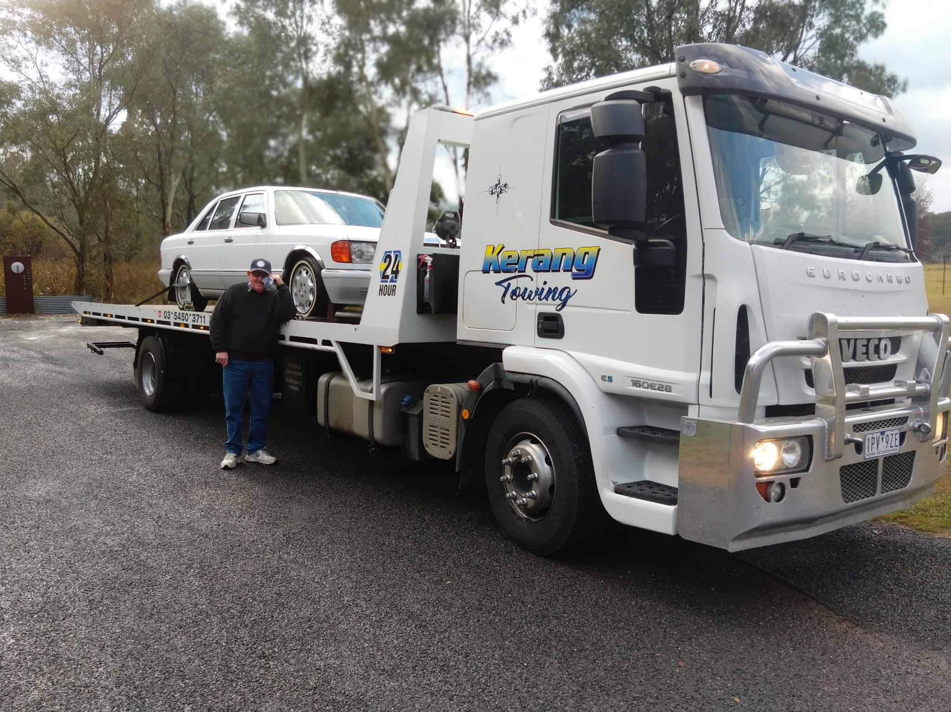

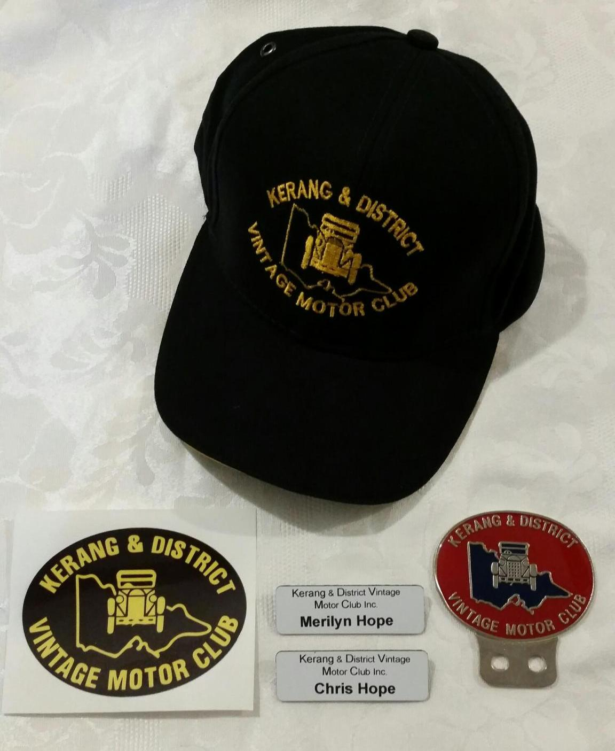

Kerang and District Vintage Motor Club
Merchandise for sale

$15 Club Caps.
$5 Club car stickers.
$30 Club car badge.
$10 Photo frame for display wall.
$10 Name badge.

See John Webb Ph. 0409 996 512

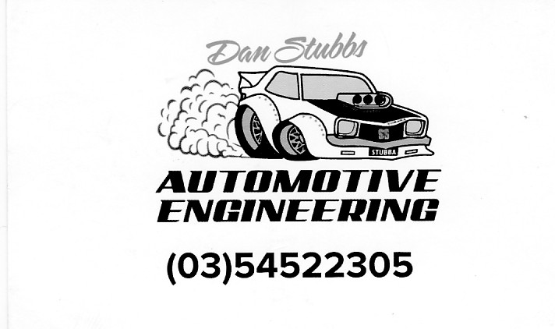

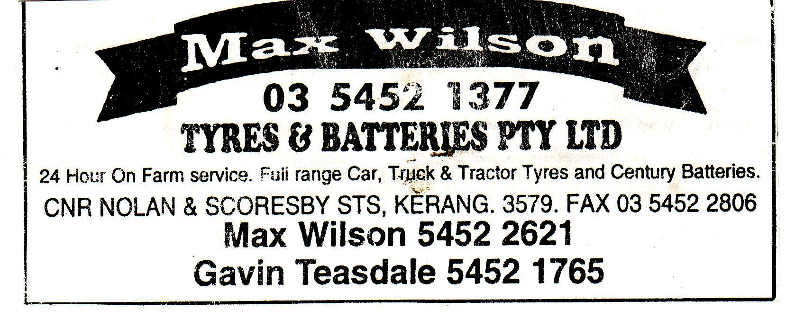


O’Brien Automotive Machining Services

*Crank Grinding *Cylinder re-bores
*Manifold repairs *Crack testing & repairs
*Line Boring *Cylinder head repairs
*Balancing *Full Engine Rebuilds
*New & Used Parts *Performance Engines

Ph 0408 855 430

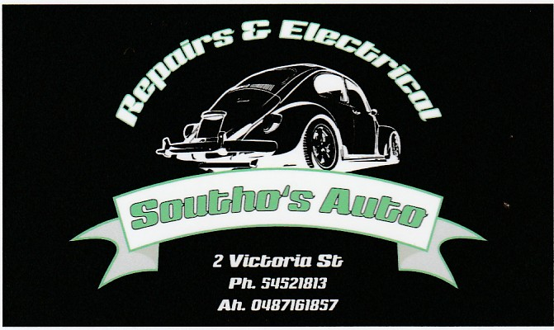

COMING EVENTS

11th & 12th of November Bendigo Swap.
18th of November Ganna Toy Run.
21st of November Club meeting.
23rd Club lunch.
15th of December Christmas Dinner at the Bower in Cohuna.
19th of December Club meeting.
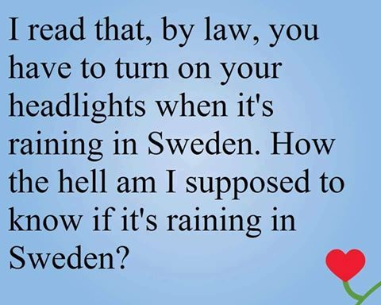
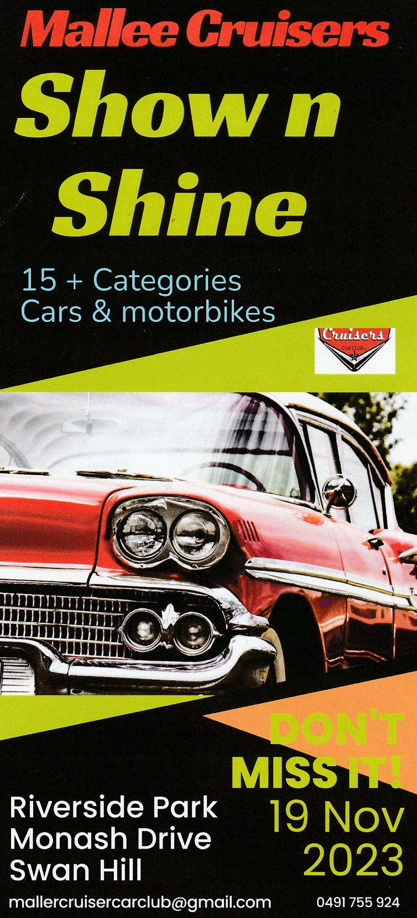

Several members attended the Moama Show and Shine.
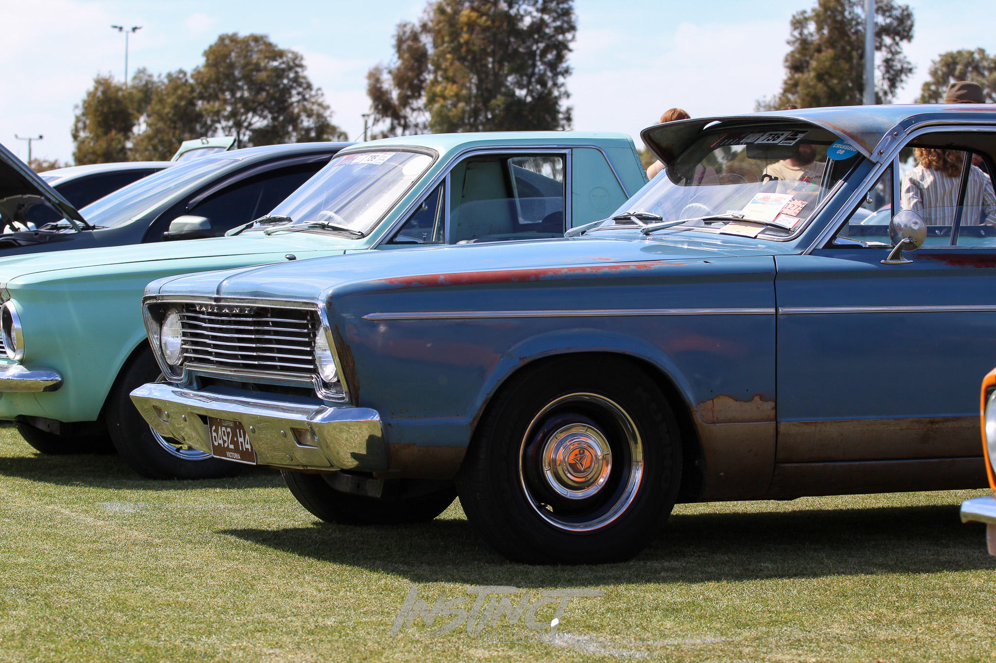
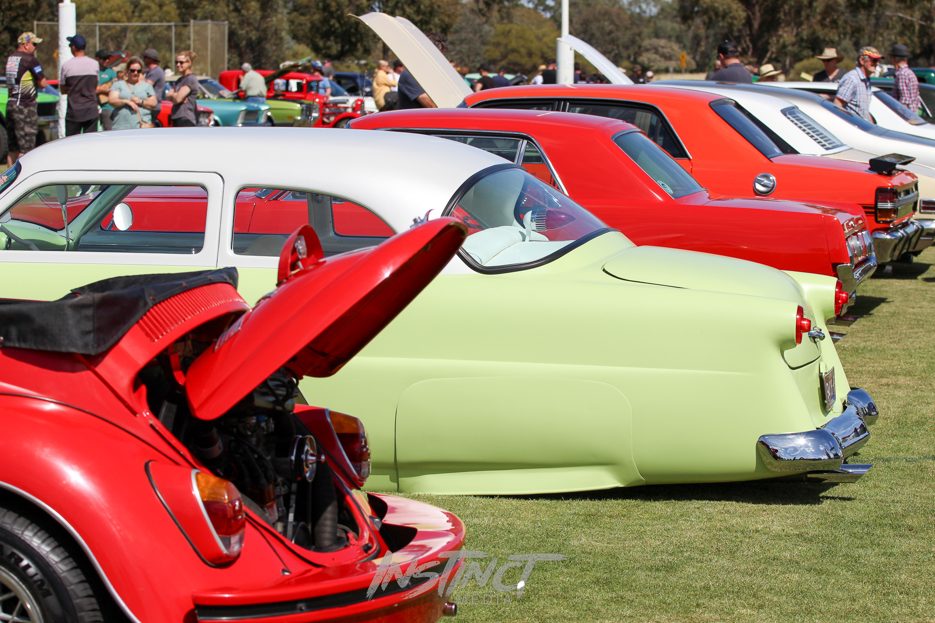
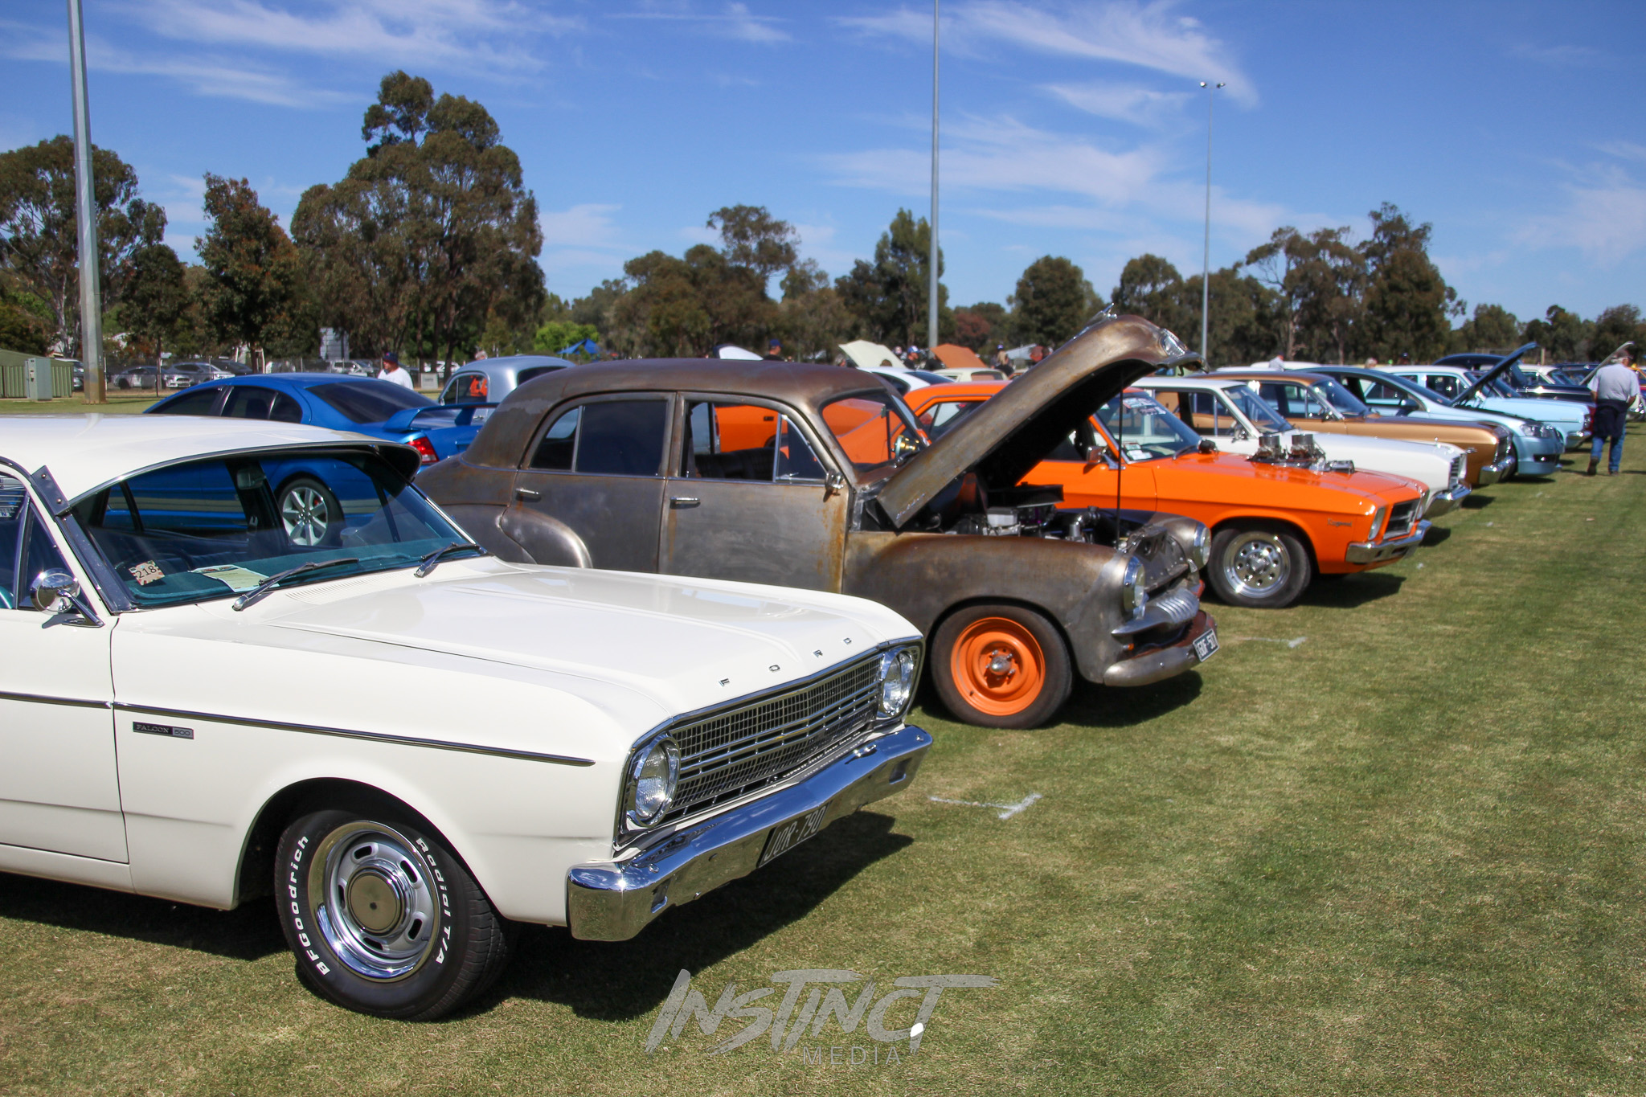

The Boort Show was attended by several members.



